Order Of Service

Singing: Psalm 51b—CW page 87

Reading: Psalm 45

Opening Hymn: TLH 1

Reading: Galatians 1:11-24

Request Hymn: CW Supplement 769

Reading: Mark 8:27-30

Sermon Hymn: TLH 459

Sermon Text: Luke 18:9-14

Two Prayers

Prayer

The Apostles’ Creed, TLH page 12

Holy Communion

The Lord's Prayer

The Blessing

Closing Hymn: TLH 45

************

Bible Study: Lambs: Wild Cat
Sheep: Deut. 1:9-18
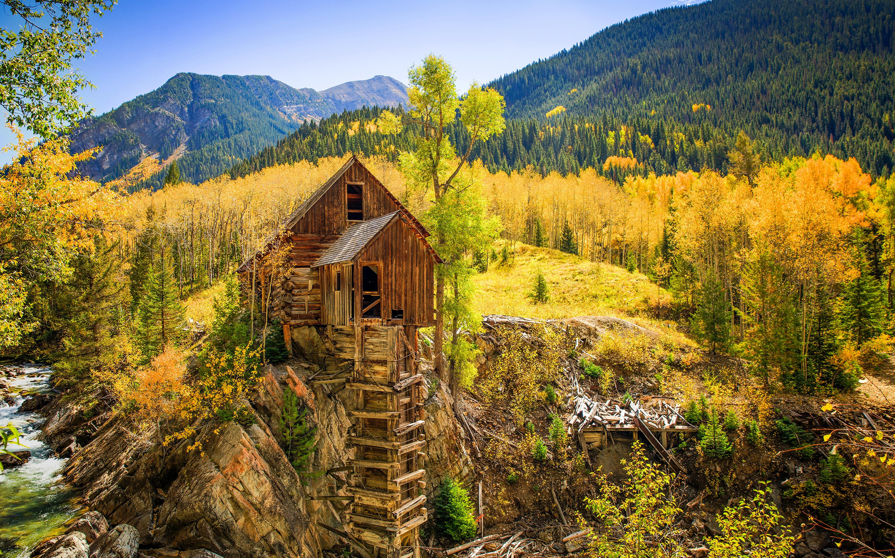

Fall In Colorado

Water
Of
Life

13 November 2022

W A T E R O F L I F E

Independent Christian Church—Conservative Lutheran Doctrine

Worship Service: 9:30 a.m.

Larry Cooper, Pastor E-Mail address:
111 N. Ridge Road lcooper@wateroflife.cc
Coon Valley, WI 54623 Web Site:
www.wateroflife.cc

* * * * * * * * * * * * * * * * * * * * * * * * * * *

Sermon Text: Luke 18:9-14

Two Prayers

* * * * * * * * * * * * * * * * * * * * * * * * * * *

9 And he spake this parable unto certain which trusted in themselves that they were righteous, and despised others:
10 Two men went up into the temple to pray; the one a Pharisee, and the other a publican.
11 The Pharisee stood and prayed thus with himself, God, I thank thee, that I am not as other men are, extortioners, unjust, adulterers, or even as this publican.
12 I fast twice in the week, I give tithes of all that I possess.
13 And the publican, standing afar off, would not lift up so much as his eyes unto heaven, but smote upon his breast, saying, God be merciful to me a sinner.
14 I tell you, this man went down to his house justified rather than the other: for every one that exalteth himself shall be abased; and he that humbleth himself shall be exalted.

